How does the Urban Heat Island(UHI) Effect impact selected neighborhoods in Chicago and Surrounding Municipalities?

ClaireYi

3/1/2019

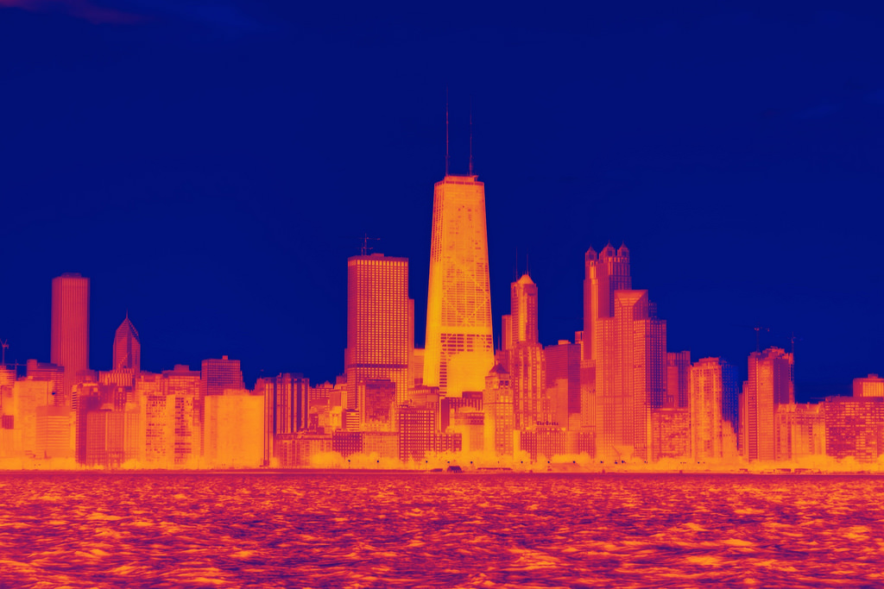 [Image Source: Phillips, Dustin]

## Introduction

The term “urban heat island” describes a metropolitan area that is significantly warmer than its surrounding rural areas due to human activities. Urban heat islands(UHI) become extremely vulnerable (Coseo and Larsen 2014) when heat and cold waves strike due to its discrepancy in heating and cooling rates and has led to high heat-related mortalities in the past, especially within marginalized communities. This has concerned urban planners, public health officials and policy makers as we are entering an era of increasingly unstable climate. To put this issue in content, we are going to zoom into the supposedly “windy city” Chicago to discuss the impact of UHI over time by analyzing the records from three different weather stations in the city. Based on results of previous studies (Coseo and Larsen 2014), I hypothesize that the temperature trend of the neighborhoods are positively correlated to their distance to downtown and coverage of green infrastructure nearby, including all green area such as parks, gardens and green roofs. We also expect the air temperature during heat waves increases with time in all three stations.

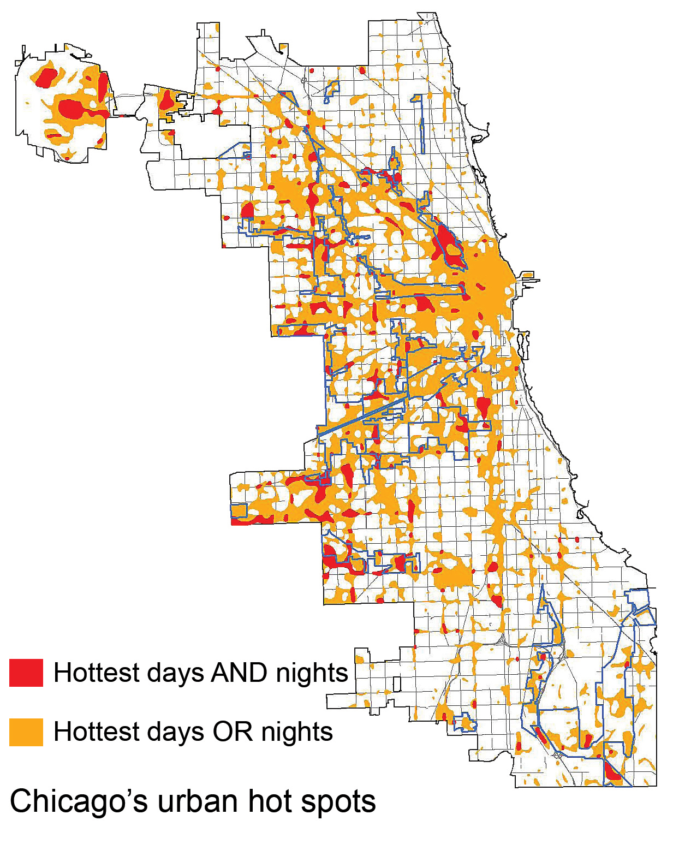 [Fig.1. Urban Heat Islands seem to occur within the city center where the highest concentration of high buildings and industrial area are.Image Source: U.S. Global Change Research Program]

## Analyzing Weather Data: is there a heating trend?

The raw data, including daily maximum and minimum temperature, was provided by National Oceanic and Atmospheric Administration (NOAA) from three weather stations located in three different neighbourhoods of Chicago: Barrington (1962/11/01-2019/02/24), Park forest (1952/09/06-2019/02/12) and Midway airport (1928/02/29-2019/02/23). Each set contains 20,000 to 30,000 days of data. However, not all datasets are complete: there is a gap between 1990 and 2020 in Barrington station. Therefore, the comparison between the three data sets should not be made during that period. The accuracy of collected data could also be compromised based on the set-ups of the stations, especially since this is a research project focused on microclimates within specific neighborhoods.

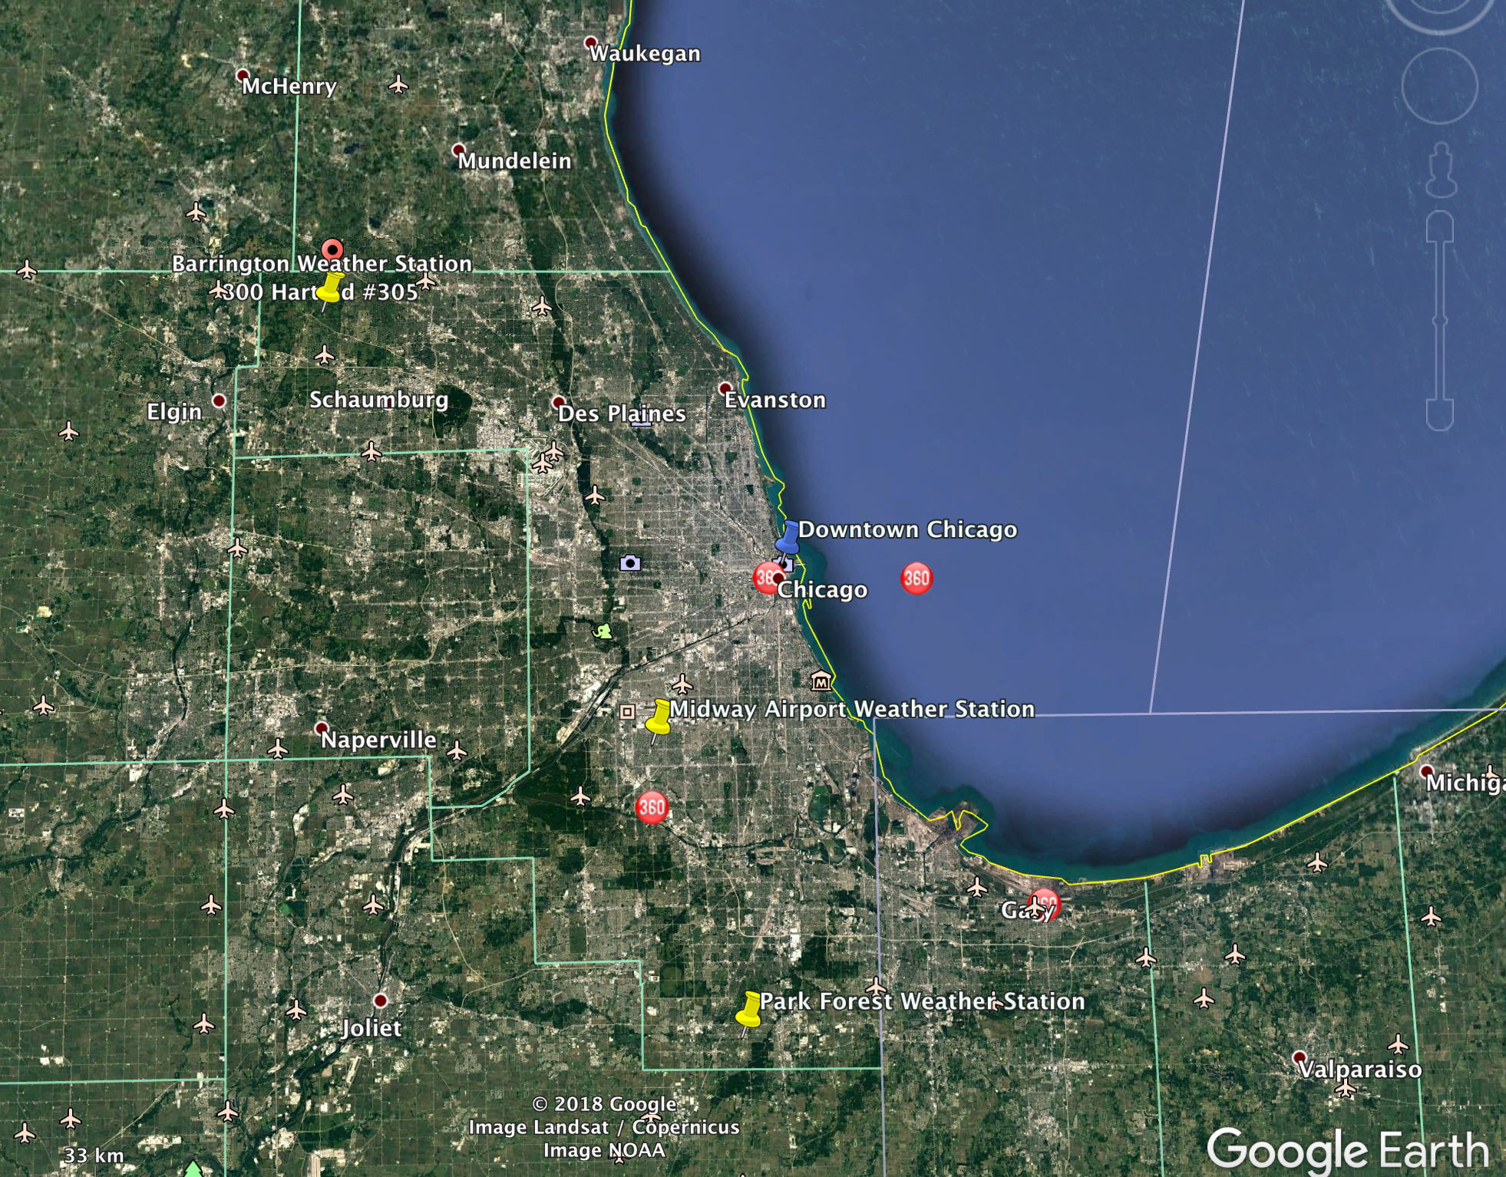 [Fig.2. Three Weather Stations in Barrington, Park Forest, and Midway Airport, IL]

Let’s start with looking at the minimum temperature(TMIN°C) of the three stations for the past 60 years to determine whether there had been a warming pattern in each of the three neighbourhoods.

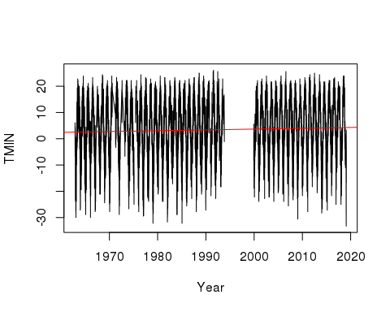

Fig.3. Minimum Daily Temperature from 1960 to 2020 in Barrington, IL

There seems to be a slight upward trend in the minimum daily temperature in our first weather station, Barrington, IL. It is possible that Barrington is relatively unaffected by the UHI effect due to its long distance from the urban center(32mi/51.4km). Let's look at our next station, Park Forest, a neighbourhood that is 28mi/45.58km from downtown Chicago.

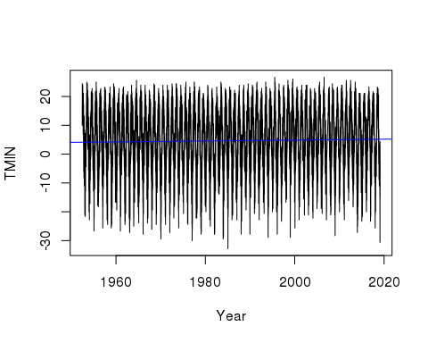

Fig.4. Minimum Daily Temperature from 1960 to 2020 in Park Forest, IL

The minimum temperature in Park forest shows a bigger upward trend than Barrington: the meanline y intercept is 4.4 comparing to the earlier 2.76. The last station we are going to look at is Midway Airport which is 12mi/20km from the city center.

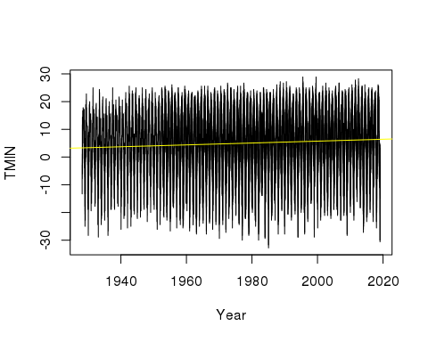

Fig.5. Minimum Daily Temperature from 1960 to 2020 in Midway Airport, IL

The meanline y intercept is 4.74, which means the minimum air temperature is increasing in a higher rate than both Barrington and Park Forest. Overall, all three weather stations have recorded a steady increase in minimum daily air temperature from 1960 to 2019.

## Is There a Correlation between UHI and Landuse Factors?

In their 2014 study (Coseo and Larsen 2014), Coseo and Larsen have identified some of the most prominent factors that could exacerbate the UHI effect in previous studies, including building configuration, proximity to industrial and traffic infrastructure, land cover variables and upwind conditions, etc. They concluded that land cover variables is the most significant contributor to UHIs at nighttime while upwind conditions contributes more during daytime. Although upwind conditions could attribute to the surrounding environment, their study did not fully explain the effect of UHI in relation to the neighborhood’s proximity to different land use and infrastructure types as the hypothesis set out to achieve. In this blog, I attempt to analyze two sets of correlations that fell into such discrepancy: correlation between proximity to urban center and coverage of green infrastructure nearby and UHI effect.

Unlike Coseo and Larsen’s research, the data I am using will only indicate daily minimum temperature. It will not detect the difference between nighttime and daytime, but will exemplify a long term temperature trend in relation to each factor. This may be more transferable as a reference for urban planners and policy makers since their work mostly concerns a larger time frame than changes within a day. Additionally, each “neighborhood” in this research is defined by geological area instead of administrative boundaries to reduce uncertainties in municipal size. I marked a circumference of 2 km (~10 city blocks) radius around each station to determine a “neighborhood” using Google Earth.

As the overall temperature warms up throughout the past few decades, the UHI effect seems to be the most significant during summer months and amplifies heat waves if they occur, according to Stone's studies (Stone 2012). Due to capacity of this blog, let’s just compare the daily minimum air temperature in the three stations during month of July in relation to each factor.

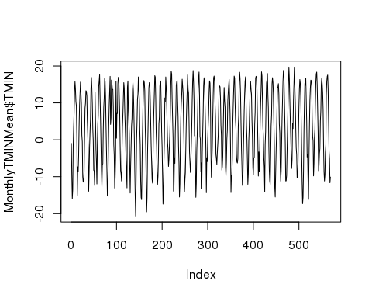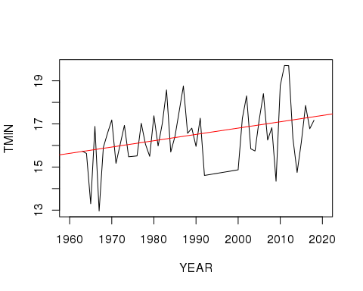

Fig.6. July Minimum Daily Temperature in Barrington, IL, 1960-2019

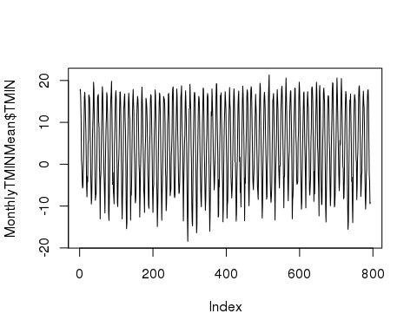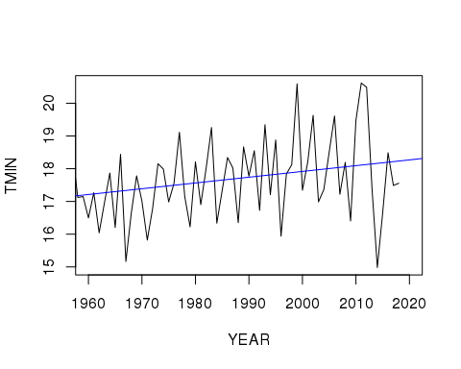

Fig.7. July Minimum Daily Temperature in Park Forest, IL, 1960-2019]

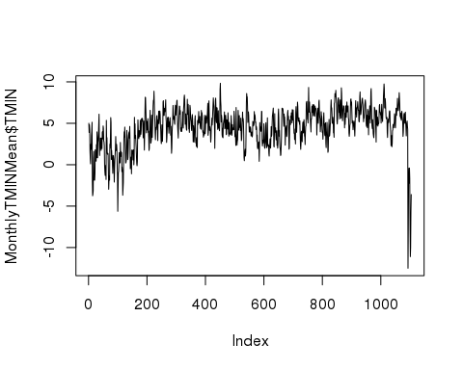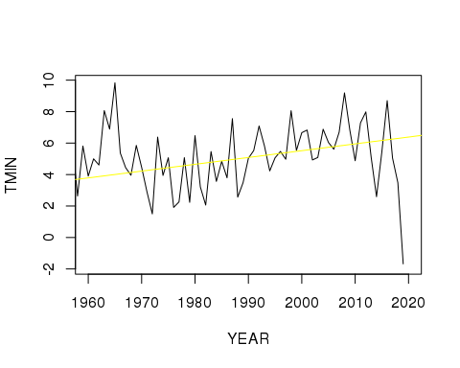

Fig.8. July Minimum Daily Temperature in Midway Airport, IL, 1960-2019]

Overall, all three stations have shown a steep increase trend in daily minimum air temperature in July fronm 1960 tp 2019. The Midway airport trend is particularly interesting: although it is a clear increase overall, there seem to be a sudden decrease since 2015. Further research is required to rationalize this sudden change.

Now let's explore the correlation between the increasing temperature and the two previously mentioned factor: proximity to urban center and number of green infrastructure.

## Is There a Correlation between Proximity to Urban Center and UHI effect?

|  |  |  |
| --- | --- | --- |
| Weather Station | Promximity to City Center (km) | Increase in TMIN in July (P Value) |
| Barrington | 51.41 | 0.015 |
| Park Forest | 45.58 | 0.023 |
| Midway Airport | 20.79 | 9.29e-07 |

[Table.1. Analysis of Minimum Daily Temperature Increase from 1960 to 2020 in relation to Distance between Weather Station and City Center]

## Is There a Correlation between Number of Green Infrastructure and UHI effect?

|  |  |  |
| --- | --- | --- |
| Weather Station | Coverage of Green Infrastructure[1] | Increase in TMIN in July (P Value) |
| Barrington | 98% | 0.015 |
| Park Forest | 30% | 0.023 |
| Midway Airport | 13% | 9.29e-07 |

The P values indicates the statistical significance of the model. The smaller P value is, the geater the evidence against the null hypothesis. As tables shown above, P value increases as both factors decrease. Although it is hard to tell to what extent each factor is influencing the temperature trend, we can accept the hypothesis that the temperature increase of the neighborhoods are positively correlated to their distance from downtown and coverage of green infrastructure nearby by associating the tables with previous plots.

I realize that the tables above do not grant the rigor or the quantity of information that is sufficient to make any definitive conclusion. I would like to acknowledge the complicated nature of climate science and urban studies in this context. There is not only a potential, but also necessity for future studies to unpack the dynamic among all factors that play a role in UHI effect.

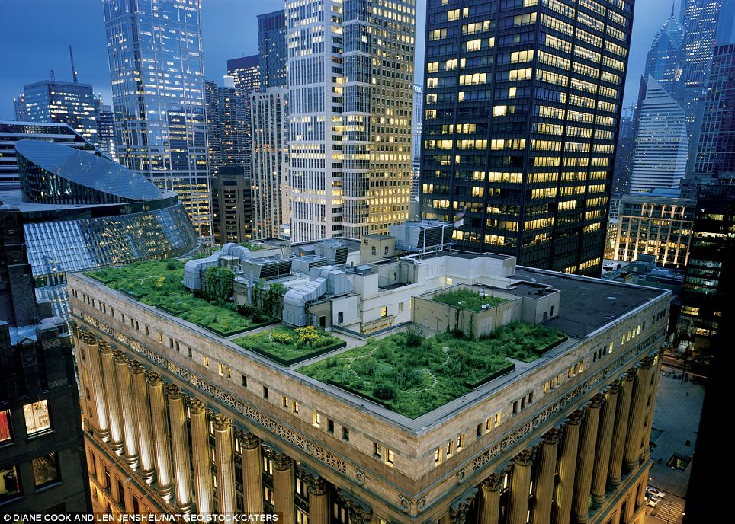 [Image Source:dailymail.co.uk]

## So What Happens Next?

As mentioned in the introduction, there has been an increasing awareness on Urban Heat Island(UHI) effect across all sectors, especially after the 1995 heat wave. It was a series of above 100 °F days in July, 1995, which led to 739 heat-related mortalities (Naughton et al. 2002), most of which occurred among the elderly (Klinenberg 2002), low-income communities. Although research has not been conducted to test a correlation between neighborhood income level and UHI impact in Chicago, similar studies (Enerette et al. 2007) was done in Phoenix, Arizona, and showed that every $10,000 increase in neighborhood annual median household income associates with 32.5 °F decrease in the surface temperature. It is worth noting, however, there is no direct impact from neighbourhood income level to air temperature; the correlation (Coseo and Larsen 2014) was observed because of the increased vegetation cover and higher maintenance associated with wealthier neighborhoods. This suggests that the impact of UHI and heat waves could be immediately reduced via urban planning and other administrative measures such as increase public green infrastructure.

However, the urban climate is no less, if not more, complicated than the natural one. Increase in green infrastructure does seem to be an effective strategy, but it also comes with other environmental drawbacks. Sharma et al. from University of Notre Dame conducted a study (Sharma et al. 2016) on green roofs as an UHI mitigation strategy using computer simulation as well as Weather Research and Forecasting model. Results showed that although green/cool roof does offset urban-induced warming--daytime peak roof surface temperature reduced linearly from 0.75 °C to 3.25 °C as green roof fraction increased from 25% to 100%--it interrupts vertical wind which leads to decrease in air quality. Additionally, the demand for water, maintenance, and increase in local humidity can make the implementation practically difficult. Overall, such green infrastructure can effectively mitigate the Urban Heat Island effect, but should be implemented in smaller patches rather than in large, continuous area to avoid problems mentioned above. There is still a lot of potential for future studies to explore other strategies in response to the UHI in the content (Meehl and Tebaldi 2004) of longer and more frequent heat waves in the future.

## Bibliography

Coseo P, Larsen L. 2014. How factors of land use/land cover, building configuration, and adjacent heat sources and sinks explain Urban Heat Islands in Chicago. Landscape and Urban Planning 125 (2014):117–129.

Jenerette et al. 2007. Regional relationships between surface temperature, vegetation, and human settlement in a rapidly urbanizing ecosystem. Landscape Ecology 22(3).

Klinenberg E. 2002. Heat Wave: a social autopsy of disaster in chicago. University of Chicago Press.

Naughton et al. 2002. Heat-related mortality during a 1999 heat wave in Chicago. AJPM 56(3):221-227.

Sharma et al. 2016. Green and cool roofs to mitigate urban heat island effects in the Chicago metropolitan area: evaluation with a regional climate model. Environ. Res. Lett. 11 (2016):064004.

Stone B, Norman JM. 2006. Land use planning and surface heat island formation: A parcel-based radiation flux approach. Atmospheric Environment, 40(2006):3561–3573.

1. Estimates made based on data from Center for Neighborhood Technology, <http://greenmapping.cnt.org/maps.php>. [Table.2. Analysis of Minimum Daily Temperature Increase from 1960 to 2020 in relation to Number of Green Infrastructur in Neighborhood]